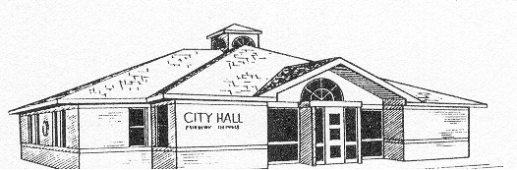 **CITY of FAIRBURY**

[**www.cityoffairbury.com**](http://www.cityoffairbury.com) **P.O. Box 228 Fairbury, Illinois 61739 ____________________________________________________________________________________________________________**

***Mayor* Lynn Dameron *City Clerk* Brenda DeFries C*ity Superintendent* Leroy McPherson**

MEETING NOTICE

PLANNING COMMISSION

WEDNESDAY, SEPTEMBER 9, 2015

12:00 NOON

City Hall (815) 692-2743 Fax (815) 692-3428 Police (815) 692-3347